​​​​CpS 109 - Introduction to Computer Programming

Fall 2023
Dr. Hughes | Instructor: | Dr. Alan Hughes
 | Office: | Alumni 76;  Alternatively, ML2a (CS lab)
 | Office Hours: | MWThF 2pm (by appt);  Tue. electronic (by appt)
 | Email: | ahughes@bju.edu (recommended method of contact)
 | Telephone: | Office: 864-242-5100 x 2274  Cell: 864-906-1024

Course Description:
An introduction to programming using a high-level language, with an emphasis on problem-solving using structured techniques and objects, and the development of problem-solving skills through programming exercises.

Course Reading(s):

Programming With Microsoft Visual Basic 2019/2022 - Diane Zak (9th edition),

ISBN: 978-0-357-674000
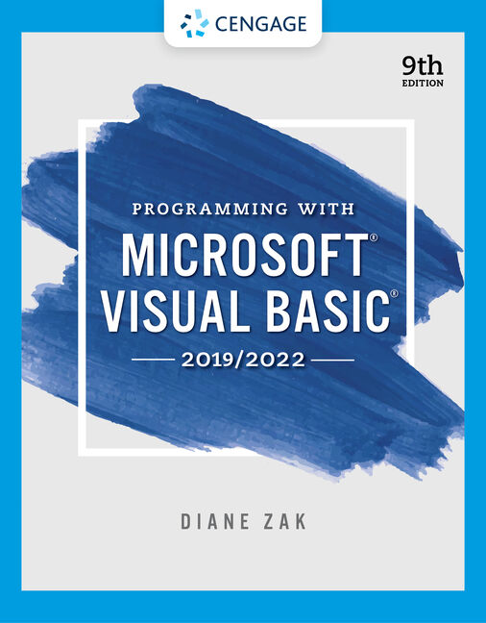

Context:
The faculty of the Computer Science department has aligned the computer science program with the goals of the Mathematical Sciences Division (MS), BJU Bible and liberal arts core objectives, and BJU institutional goals. The goal of the Computer Science department is to align all courses in the Computer Science and Information Technology majors to support one or more of the following departmental goals. An asterisk indicates a goal fulfilled by this course.
- Design and implement solutions to practical problems *
- Use appropriate technology as a tool to solve problems in various domains
- Create efficient solutions at the appropriate abstraction level
- Demonstrate an ability to work effectively in teams
- Demonstrate an ability to communicate technological information effectively both in written and oral forms
- Demonstrate an ability to acquire new knowledge in the computing discipline *
- Demonstrate an understanding of social, professional and ethical considerations related to computing
- Demonstrate understanding of fundamental concepts in the (student's) discipline *
- Prepare students for graduate school or to secure employment in a related area

CpS 109 Course-specific Goals:
- Design and implement solutions to practical problems.
- Demonstrate an ability to acquire new knowledge in the computing discipline.
- Demonstrate understanding of fundamental concepts in the discipline.
- Provide the student a platform for continued learning and development of his/her God-given abilities.
- Instill in the student a desire to use his/her abilities in service to Christ.

Learning Objectives:
At the end of the course, students should be able to:
Learning Objective | Assessment Tools
Analyze and explain the behavior of simple programs involving the fundamental programming constructs covered by this course. | Quizzes, Tests, Final Exam
Design, implement, test, and debug programs that use each of the following fundamental programming constructs: | Programming Projects, Lab Tests, Quizzes
Choose appropriate conditional and iterative constructs for a given programming task. | Programming Projects, Tests, Quizzes
Describe the mechanics of parameter passing. | Quizzes, Written Tests
Use VB.NET to implement, test, and debug algorithms for solving simple problems. | Programming Projects, Lab Tests
Correctly identify and use of primitive data types in computer programs. | Quizzes, Programming Projects, Tests

Course Policies:

Qualifications
CpS 109 is for students with a Math ACT greater than 21 or who have placed into Ma 103.

Absences, lateness, and makeup opportunities
- The overarching guide for class attendance is the BJU Class Attendance Policy.
- For planned absences, please email me one week in advance.
- Written assignments should be submitted before your planned absence.
- Scheduled tests and quizzes should be taken before your planned absence; please contact me to make arrangements for doing so.
- For absences due to incapacitating illness or emergency, you should contact me as soon as you are able to return to class in order to make arrangements for making up any graded work without penalty.
- In other circumstances, tests and quizzes may be made up within one week of your return, with a 10 percent grade penalty for that test or quiz.
- Leaving class early without prior arrangement will constitute an absence.
- Each absence costs 2 class participation points; each late costs 1 class participation point.

Late Work:
- Assignments must be submitted using the electronic submission system before 11:59pm on the day due.
- The use of the submission system will be explained during the first week of class.
- Only work missed for legitimate reasons may be made up without penalty. Legitimate reasons include illness, a death in the family, or a BJU sanctioned tour.
- You must make up late work according to the number of days missed - that is, missing one day of class gives you one extra day to turn in your work.
- Any other late work will receive a 20% grade penalty.
- All late work must be made up within one week in order to receive a non-zero grade.

Grade appeals:
- Grading appeals must be made by email only no later than one week after the grade was assigned.
- Appeals will be automatically denied if the student attempts to make the appeal verbally.
- Email grading appeals should be made respectfully and logically (My grade should be increased because).

Academic Integrity
- The overarching guide for academic integrity is the BJU Academic Integrity Policy.
- Cheating on assignments and tests is a form of deception and stealing, and as such, is prohibited by Scripture and will incur academic penalties.
- Since the goal of the assignments in this course is to learn to develop the skills covered NOT complete the tasks assigned, and since the use of AI to complete or jumpstart tasks defeats the goal of the assignments, you may not use generative AI tools (i.e. Chat GPT, Bing Chat, Google Bard, etc.) in this course for any assignment without the professors express permission. Should an AI tool be used with permission, its use must be documented.
- All work is to be done individually unless Dr. Hughes gives permission for group work.
- In general students are encouraged to assist one another in debugging programs, but must exercise care when seeking assistance while writing code.
- Each student needs to become familiar with Visual Basic, and be able to write programs on his or her own. Therefore, please do not copy code from another person, as this constitutes cheating.

Class Participation:
- Compliance with the BJU Student Handbook policies is expected during class.
- Class participation grades are based upon actively participating in lecture class discussions, working diligently on course assignments in lab classes and being respectful to the rest of the class and the instructor.
- Playing games, electronic messages, working on other subjects, etc. is a demonstration of disrespect for both the instructor and other students, and is not allowed during lecture or lab classes. This includes the use of cell phones or other devices not employed for class work.

Instructor Help Outside of Class

You are encouraged to use email (recommended) or the telephone to ask Dr. Hughes for assistance.

Copyright Policy:
Copyright 2009-2023 Alan Hughes as to this syllabus and all lectures. Students are prohibited from selling (or being paid for taking) notes during the course to, or by any person, or commercial firm without the express written permission of the professor teaching the course.

Schedule (subject to modification as needed, during the semester)​
Please note test dates and project due dates. ​ ​ ​
Date | Day | Class | Assignment Due
Aug 23 | W | Introductions; syllabus overview; First look at Visual Basic Community (2019 or 2022)  Practice Project  Download Visual Studio Community  Be sure to register if it asks you to do so. Once it is downloaded and installed, click Help to see if it wants you to register. | Read Chapter 1; Review Syllabus
Aug 25 | F | Lab – Practice Project | Practice Project Due(Hello World)
Aug 28 | M | Chapter 1 – Create an App; Windows in VS; Properties; Save a Solution | Read Chapter 1
Aug 30 | W | Chapter 1 – Adding controls; adding code; Assignment statements; comments; pseudocode
Sep 1 | F | Lab
Sep 4 | M | Labor Day
Sep 6 | W | Chapter 2 – Designing the User Interface (labels, textboxes) | Quiz 1  Read Chapter 2
Sep 8 | F | Lab – hotkeys, tab order | Project 1 (Weather) due
Sep 11 | M | Chapter 3 – variables and memory; data types and names; DIM statements; TryParse | Quiz 2  Read Chapter 3
Sep 13 | W | Chapter 3 – arithmetic; ToString; named constants
Sep 15 | F | Lab
Sep 18 | M | Chapter 4 – Selection structures, if-then-else | Read Chapter 4  Quiz 3
Sep 20 | W | Chapter 4 – comparisons and logical operators; string comparisons
Sep 22 | F | Lab – Select-Case statements; checkboxes and radio buttons | Project 2 (Car Rental)
Sep 25 | M | Test 1 (Ch 1-4) | Read Chapter 5  Quiz 4
Sep 27 | W | Chapter 5 – Loops, infinite loops, Do-while, for-next; list boxes and loops
Sep 29 | F | Chapter 5
Oct 2 | M | Chapter 6 – sub-procedures and function procedures | Quiz 5
​Oct 4 | ​W | Chapter 6 – passing parameters; comboboxes
​Oct 6 | ​F | Lab Test 1
​Oct 9 | ​​M | Chapter 7 – Strings;; padding; trimming, | Quiz 6  Project 3 (Summer Reading)
Oct 11 | W | Chapter 7 – substrings; Random numbers,
Oct 13 | F | Lab
Oct 16-17 | M | Fall Break
Oct 18 | W | Chapter 8 –Arrays; storing data | Quiz 7
Oct 20 | F | Chapter 8 – traversing an array; two-dimensional arrays
Oct 23 | M | Chapter 9 – Menus, sequential files | Quiz 8
Oct 25 | W | Chapter 9 – Sequential files
Oct 27 | F | Lab | Project 4 (Taste Test)
Oct 30 | M | Chapter 10 – Classes and objects | Quiz 9
Nov 1 | W | Chapter 10 – constructors; overload methods
Nov 3 | F | Lab
Nov 6 | M | Chapter 11 – SQL Server Databases | Quiz 10
​Nov 8 | W | Chapter 11 – SQL Server Databases
Nov 10 | F | Lab | Project 5 (Burgers and Booths)
Nov 13 | M | Chapter 11
Nov 15 | W | Chapter 11 | Quiz 11
Nov 17 | F | Test 2 (Ch 5-9)
Nov 20-24 | M-F | Thanksgiving Break
Nov 27 | M | Data Structures
Nov 29 | W | Data Structures
Dec 1 | F | Lab – Personal project | Project 6 (Yacht Rental, using data structures)
Dec 4 | M | Lab – Personal project
Dec 6 | W | Lab – Personal project
Dec 8 | F | Lab Test 2 | Personal Project (Saturday)
Dec 11 | W | Final Exam (Ch 10,11,13) 2:00-3:10pm

Grading
# | Item | Pts. | Total
12 | Quizzes | 30 | 360
6 | Programming projects (labs) | 40 | 240
1 | Personal Project | 100 | 100
1 | Lab Test 1 | 50 | 50
1 | Lab Test 2 | 150 | 150
2 | Tests | 100 | 200
1 | Final Exam | 100 | 100
​ | TOTAL | ​ | 1200

Grade | Score
A | 90-100
B | 80-89
C | 70-79
D | 60-69
F | < 60

