Network, Server, and Cloud Administration

Fall 2023
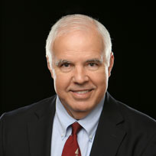​  Instructor: Dr. Alan Hughes | Office: | AL76  Alternatively, MB203 (CS lab in library)
 | Office Hours: | MWThF 2pm; Tuesday, electronic; alternatively in CS Lab (MB203) by appointment
 | Email: | ahughes@bju.edu (best, fastest way to reach me during the week)
 | Telephone: | Cell: 864-906-1024  Office: 86-242-4100 x​2274

​Course Description:
This course deals with administration issues that affect the planning, setup, and maintenance of computer servers and networks. Issues such as account policies, storage management, security, licensing, performance monitoring, providing support for a large user community, providing network services, etc. You will gain experience setting up a network with Linux servers, as well as network switches and routers. You will also set up a cloud infrastructure in Amazon’s AWS.

Course Reading(s):
CompTIA Cloud+ Guide to Cloud Computing, Jill West, 1st Edition, Copyright 2021, ISBN-13: 978-0357541395; ISBN-10: 0357541391
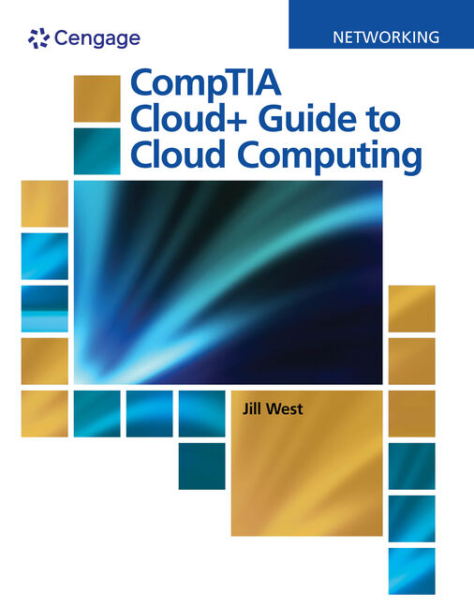​​
Context:
The faculty of the Computer Science department has aligned the computer science program with the goals of the Mathematical Sciences Division, BJU Bible and liberal arts core objectives, and the BJU institutional goals. The goal of the Computer Science department is to align all courses in the Computer Science and Information Technology majors to support one or more of the following departmental goals:
- Design and implement solutions to practical problems.
- Use appropriate technology as a tool to solve problems in various domains.
- Create efficient solutions at the appropriate abstraction level.
- Demonstrate an ability to work effectively in teams.
- Demonstrate an ability to communicate technological information effectively both in written and oral forms.
- Demonstrate an ability to acquire new knowledge in the computing discipline.
- Demonstrate an understanding of social, professional and ethical considerations related to computing.
- Demonstrate understanding of fundamental concepts in the student's discipline.
- Prepare students for graduate school or to secure employment in a related area.

Course Goals:
- Design and implement solutions to practical problems.
- Demonstrate an ability to work effectively in teams.
- Demonstrate an ability to communicate technological information effectively both in written and oral forms.
- Demonstrate an ability to acquire new knowledge in the computing discipline.
- Demonstrate understanding of fundamental concepts in the discipline
- Provide the student a platform for continued learning and development of his or her God-given abilities.
- Instill in the student a desire to use his abilities in service to Christ.

Learning Objectives:
At the end of the course, students should be able to:
Learning Objective | Assessment Tools
Understand the role and responsibilities of a system administrator. | Lab Projects; Quizzes; Tests
Understand private and public cloud infrastructures, advantages, disadvantages, and security concerns | Research Papers; Lab Projects, Quizzes; Tests
Install, configure and understand the operations of a Linux server. | Lab Projects; Quizzes; Tests
Install, configure and understand the operations of a Windows server. | Lab Projects; Quizzes; Tests
Set up and manage user accounts and groups in both Linux and Windows. | Lab Projects; Quizzes; Tests
Set up and perform basic configuration of representative Ethernet switches and routers. | Lab Projects; Quizzes; Tests
Set up a basic cloud-like server infrastructure | Lab Projects
Migrate a basic infrastructure to AWS | Lab Projects
Understand Biblical ethics required of a faithful Christian working as a system and network administrator or manager | Writing assignments

Course Policies:

Qualifications
CpS 433 is for students who have completed CpS 335 and (CpS 202 or CpS 320).

Absences, lateness, and makeup opportunities
- The overarching guide for class attendance is the BJU Class Attendance Policy.
- For planned absences, please email me one week in advance.
- Written assignments should be submitted before your planned absence.
- Scheduled tests and quizzes should be taken before your planned absence; please contact me to make arrangements for doing so.
- For absences due to incapacitating illness or emergency, you should contact me as soon as you are able to return to class in order to make arrangements for making up any graded work without penalty.
- In other circumstances, tests and quizzes may be made up within one week of your return, with a 10 percent grade penalty for that test or quiz.
- Leaving class early without prior arrangement will constitute an absence.

Late Work
- Assignments must be submitted using the electronic submission system before midnight on the day due.
- The use of the submission system will be explained during the first week of class.
- Only work missed for legitimate reasons may be made up without penalty. Legitimate reasons include illness, a death in the family, or a BJU sanctioned tour.
- You must make up late work according to the number of days missed - that is, missing one day of class gives you one extra day to turn in your work.
- Any other late work will receive a 20% grade penalty.
- All late work must be made up within one week in order to receive a non-zero grade.

Grade appeals
- Grading appeals must be made by email only no later than one week after the grade was assigned.
- Appeals will be automatically denied if the student attempts to make the appeal verbally.
- Email grading appeals should be made respectfully and logically ("My grade should be increased because...").

Academic Integrity
- The overarching guide for academic integrity is the BJU Academic Integrity Policy.
- Cheating on assignments and tests is a form of deception and stealing, and as such, is prohibited by Scripture and will incur academic penalties.
- Since the goal of the assignments in this course is to learn to develop the skills covered NOT complete the tasks assigned, and since the use of AI to complete or jumpstart tasks defeats the goal of the assignments, you may not use generative AI tools (i.e. Chat GPT, Bing Chat, Google Bard, etc.) in this course for any assignment without the professors express permission. Should an AI tool be used with permission, its use must be documented.
- All work is to be done individually unless Mr. Hughes gives permission for group work.
- The goal is for each student to become familiar with network, server, and cloud administration, and be able to work effectively on his or her own. Therefore, please do not copy work from another person, as this constitutes cheating. Group projects will be specifically assigned.

Class Participation
- Compliance with student handbook policies, including the dress code, is expected during class.
- Class participation grades are based upon actively participating in lecture class discussions, working diligently on course assignments in lab classes and being respectful to the rest of the class and the instructor.
- Class participation grade will include in-class assignments throughout the semester that will be individually graded.
- Playing games, electronic messages, working on other subjects, etc. is a demonstration of disrespect for both the instructor and other students, and is not allowed during lecture and lab classes.
- Dress for presentations should be professional, above normal class dress.

Instructor Help outside of class

You are encouraged to use email or the telephone to ask Dr. Hughes for assistance.

Copyright Policy
Copyright 2009-2023 Alan Hughes as to this syllabus and all lectures. Students are prohibited from selling (or being paid for taking) notes during the course to, or by any person, or commercial firm without the express written permission of the professor teaching the course.

Schedule (subject to modification during the semester as necessary):
Date | Day | Class | Assignment Due
Week 1
Aug 24 | Th | Introductions, Syllabus, Introduction to Cloud Computing | Read Chapter 1
Week 2
Aug 29 | T | Virtual Hardware | Quiz 1  Read Chapter 2
Aug 31 | Th | Building a Virtual Infrastructure – Windows and Linux Server VMs
Week 3
Sep 5 | T | Building out the servers – AD, DNS, DHCP, Proxmox | Lab 1 (initial VMs)  Quiz 2
Sep 7 | Th | Building out the servers, cont’d
Week 4
Sep 12 | T | Building out the servers, cont’d
Sep 14 | Th | Building out the servers, cont’d
Week 5
Sep 19 | T | Migration to the Cloud | Lab 2 (research cloud providers)  Quiz 3  Read Chapter 3
Sep 21 | Th | Building your network (switch attaches to internal network)
Week 6
Sep 26 | T | Cloud Infrastructure | Lab 3 (research serverless, containers, VMs and compare)  Read Chapter 4
Sep 28 | Th | Test 1 (Ch 1-3)  Building your network (finish it up) | Test 1 (Ch 1-3)
Week 7
Oct 3 | T | Cloud Connectivity | Lab 4 (infrastructure diagrams)  Quiz 4  Read Chapter 5
Oct 5 | Th | Cloud Troubleshooting
Week 8
Oct 10 | T | Securing Cloud Resources | Read Chapter 6  Quiz 5
Oct 12 | Th | Securing Cloud Resources
Week 9
Oct 17 | T | Fall Break
Oct 19 | Th | Identity and Access Management | Lab 5 (security infrastructure and policies)  Quiz 6  Read Chapter 7
Week 10
Oct 24 | T | Work Day in Lab | Quiz 7
Oct 26 | Th | Work Day in Lab | Lab 6 (ID and Access Mgt implemented)
Week 11
Oct 31 | T | Cloud Storage | Read Chapter 8  Quiz 8
Nov 2 | Th | Test 2 (Ch 4-8) | Test 2 (Ch 4-8)
Week 12
Nov 7 | T | Managing Cloud Capacity | Lab 7 (Build a private cloud)  Read Chapter 9
Nov 9 | Th | Managing Cloud Performance
Week 13
Nov 14 | T | Cloud Automation | Lab 8 (migration plan)  Quiz 9  Read Chapter 10
Nov 16 | Th | Cloud Automation
Week 14 |  | Thanksgiving Break!
Week 15
Nov 28 | T | Prepare presentations | Quiz 10  Lab 9 (migrate infrastructure to the cloud)
Nov 30 | Th | Test 3 (Ch 9-10)  Prepare presentations | Biblical Ethics of Network/Server Administration
Week 16
Dec 4 | T | Presentations | ALL Presentations in dropbox before class.  Lab 10 – Implement Kubernetes on your local infrastructure
Dec 6 | Th | Presentations | ​Final Lab Document and Presentation PPT
Final Exam
Dec 12 | T | Final Exam – 2:00-3:10pm (Comprehensive) | If you pass either the CompTIA Cloud+ Exam or the AWS Practitioner Exam before the final, assuming you have a B- or better in the class, you are exempt from the final exam.

​Grading
# | Item | Pts. | Total
10 | Quizzes | 30 | 300
3 | Tests (100, 150, 80) |  | 330
10 | Labs | 35 | 350
1 | AWS Cloud Project Document | 200 | 200
1 | AWS Cloud Project Presentation | 100 | 100
1 | Research Paper (Administrator Ethics) | 100 | 100
1​ | Final Exam | 150 | 150
​ | Class Participation (peer-evaluated) | 100 | 100
​ | ​ | ​ | ​
 | TOTAL​ |  | 1730

Scale
A | 90-100
B | 80-89
C | 70-79
D | 60-69
F | < 60​

​​​

